I’m Running Across America for You: A Student’s Pledge to do Something Big for Those Impacted by Cancer

By Alexus Barnhart

One student’s drive to give back combined with her love for running has inspired her to do something big with her upcoming summer. She’s running over 4,000 miles across America.
Her avid hobby for running started at just 12 years old when she decided to run her first Turkey Trot, and has since then progressed into something that’s helping her better the lives of cancer patients and their families.
Haley Kenyon, a Flagler College sophomore, 20, has taken the leap and decided to take on her biggest run yet. Through the 4K for Cancer, Kenyon wants to pay tribute to both her father and grandmother who endured their own personal experiences with cancer.
Kenyon’s father, who has been credited for motivating her love for running, was diagnosed with skin cancer when she was 14, and her grandma with stage four lung cancer close to three years later.
While her father made a healthy recovery, Kenyon lost her grandmother after she battled the disease for six months.
“That was my main motivation to do this. I thought it was a good cause and that I would do it for her, and since my dad is pretty much my motivator for running, I thought I would do it for him too,” said Kenyon.
The 4K for Cancer is a marathon put on by the Ulman Cancer Fund for Young Adults (UCF). UCF’s mission is to “Change lives by creating a community of support for young adults, and their loved ones, impacted by cancer,” according to UCF’s website.
The run will be comprised of three teams, Team Boston, Team Baltimore and Team New York. Each team will have 30 runners between the ages of 18-25. All participants will start in San Francisco on June 17, and end in one of the three cities the teams are named after 49 days later on August 4.
Kenyon is one of the 26 runners who have signed up so far to be a part of team New York who will be running across the northern route of the United States. Some states on the New York team’s route include: ID, UT, CO and PA.
In addition to her 20-week long training program to complete the run, Kenyon and all 90 runners are looking to raise money for the cancer patients they wish to help.
So far, Kenyon has raised $2,733.17 of her final goal of $4,500.
The funds Kenyon is hoping to raise all go back into the cancer community to provide things like scholarships, housing and treatment programs for those affected by cancer.
During the 2017-2018 school year so far, she has hosted local fundraisers through chain restaurants like Panera Bread and Chipotle, but is looking to do more on-campus fund raising when the opportunities present themselves.
Recently, on campus, Kenyon has sold flowers for Valentine’s Day and she hosted a bone marrow transplant drive in effort to add more names to the national bone marrow registry.
Kenyon also has a personal donation page where people can donate to her cause and leave comments for her to look back on. Friends and family have left encouraging compliments like:
“Amazing girl!” –Sarah Frank
“Run like the wind, Haley” You are a shining star!!” – Peter and Dorothy.
Each comment reminds Kenyon of all her loving support and commends the runner on her next marathon journey.
In addition to wanting to give back to a cause close to her heart, Kenyon says she really just enjoys running and how it makes her feel while she’s doing it.
“It’s a very strange feeling. I’ve never felt anything before like when I ran a marathon. It was very painful, but it was a good pain. I don’t know how to describe that in normal words, but it was very enjoyable pain. Like I knew what I was doing was important to me so I felt accomplished doing it,” said Kenyon.
After participating in close to 30-40 runs ranging from 5K’s, 10K’s and half marathons over the last eight years, Kenyon most looks forward to the experience the 4K for Cancer will give her. She’s excited to meet new people, including her teammates and the cancer patients they’ll be meeting during their planned service days at the various local hospitals in the cities they’ll be visiting.
Service days give the runners the opportunity to see first hand the impact they’re making on the cancer community they’re running for.
“I just think overall the experience is going to be something that’s going to stick with me forever, probably. I just think that that whole experience is going to be very worthwhile. “

If you’re interested in helping Haley give back to the Ulman Cancer Foundation for Young Adults you can visit her donation page here: https://ulman.z2systems.com/haley-kenyon

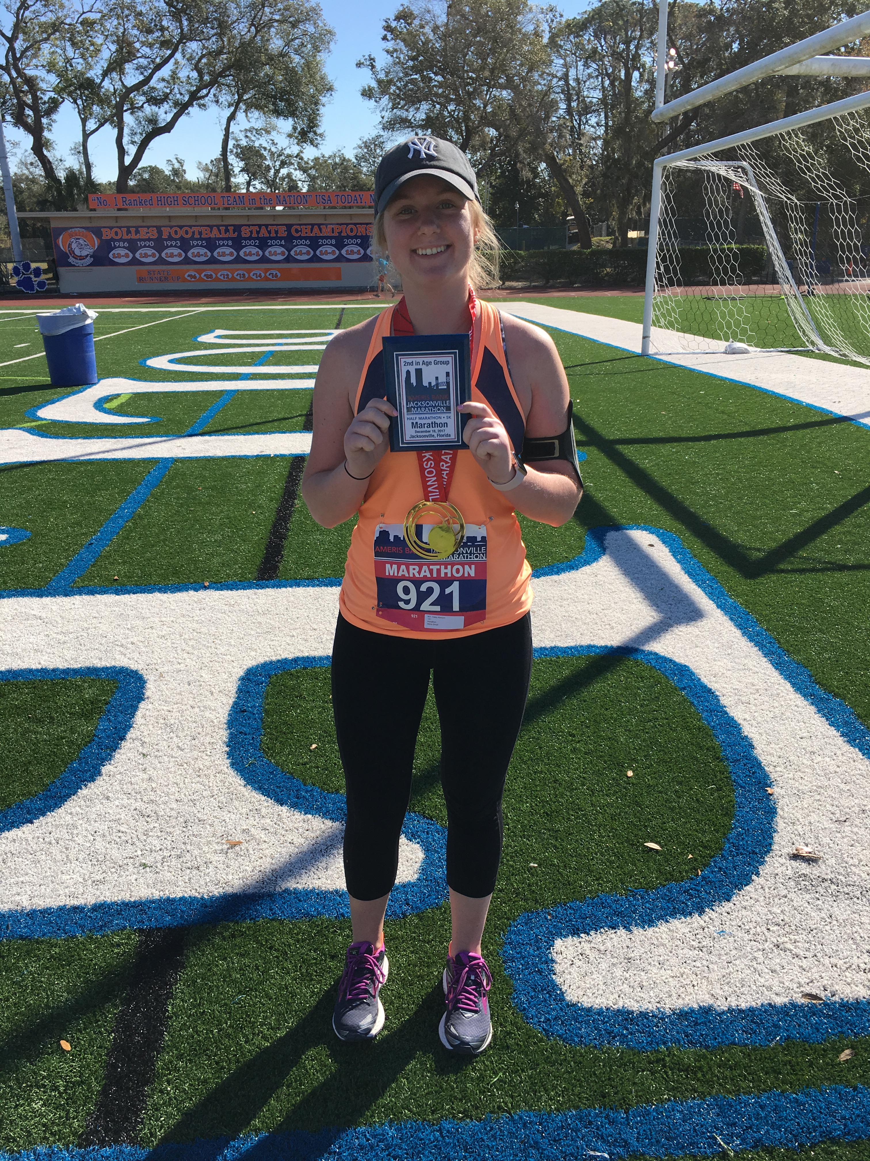
Photo courtesy of Haley Kenyon

